class D : public A, public B, public C {.........}
If we dont store the base classes' vptrs in derived objects, that
means you have to club all the virtual functions of all the base
classes (in case of multiple inheritance) into one vtbl that has a
single vptr that will be stored in your object. Now, no problem in
accessing virtual functions of first subobject (like class A in the
above code snippet) whose virtual function pointers are stored in
starting location of vtbl. But what happens in accessing other
subobjects (like classes B and C in the above code snippet) virtual
functions. Their offsets will get disturbed as you have clubbed all
the virtual functions into one vtbl. After all, compiler will access
virtual functions with their offsets only. Now you dont know what will
be get called.
Thats why in case of single or pure multilevel inheritance you dont hv
to store the base classes' vptrs in derived objects.
Now the question: Can not compiler determine these changes in offsets
and adjust virtual functions pointers accordingly? It may, it depends
on the compiler. But most of the compilers adopt this strategy and may
some compilers do this optimization.

Yes, with multiple inheritance, obviously A, B, and C cannot all share
the same starting address as D, so yes, there must be an offset on the
address of the _data_ of the object, when calling superclass functions
(of all but 1); and there must be distinct vtable addresses for all but
1 also. But like you, I cannot think why this cannot be calculated. My
only suggestion is that perhaps it is a performance issue. But even
here, surely all such objects will have the same relationships, so the
extra addresses could be stored in the vtable, I would have thought.

#include<iostream.h>
class Base1
{
public:
int a;
virtual void func1() { cout << "Base1::func1()" << endl; }
virtual void func2() { cout << "Base1::func2()" << endl; }
};
class Base2 {
public:
virtual void func1() { cout << "Base2::func1()" << endl; }
virtual void func2() { cout << "Base2::func2()" << endl; }
};
class Base3 {
public:
virtual void func1() { cout << "Base3::func1()" << endl; }
virtual void func2() { cout << "Base3::func2()" << endl; }
};
class Derive : public Base1, public Base2, public Base3
{
public:
int b;
virtual void disp1()
{
cout << "Derive::disp1" << endl;
}
virtual void Fnc()
{
cout << "Derive::disp2" << endl;
}
};
typedef void(*function)(void);
int main()
{
Derive obj;
function func = NULL;
//Size contains the _vptr of all it's base classes and Base class data and it's own
//Data
cout<<"Size of obj = "<<sizeof(obj)<<endl;
// calling 1st virtual function of Base1
func = (function)*((int*)*(int*)((int*)&obj+0)+0);
func();
// calling 2nd virtual function of Base1
func = (function)*((int*)*(int*)((int*)&obj+0)+1);
func();
//Next location contains the Base1's data, lets change it and check the o/p
int* pInt = (int*)&obj+1;
*(pInt+0) = 30;
cout<<"Base1 class fields: a =" << obj.a <<endl;
// calling 1st virtual function of Drive
func = (function)*((int*)*(int*)((int*)&obj+0)+2);
func();
// calling 2nd virtual function of Drive
func = (function)*((int*)*(int*)((int*)&obj+0)+3);
func();
// calling 1st virtual function of Base2
func = (function)*((int*)*(int*)((int*)&obj+2)+0);
func();
// calling 2nd virtual function of Base2
func = (function)*((int*)*(int*)((int*)&obj+2)+1);
func();
// calling 1st virtual function of Base3
func = (function)*((int*)*(int*)((int*)&obj+3)+0);
func();
// calling 2nd virtual function of Base3
func = (function)*((int*)*(int*)((int*)&obj+3)+1);
func();
//At the end, it contains it's own data i.e. Derive classes data, lets change it and
//check the o/p
pInt = (int*)&obj+4;
*(pInt+0) = 100;
cout<<"Derive class fields: b =" << obj.b <<endl;
return 0;
}
output
---------
Size of obj = 20
Base1::func1()
Base1::func2()
Base1 class fields: a =30
Derive::disp1
Derive::disp2
Base2::func1()
Base2::func2()
Base3::func1()
Base3::func2()
Derive class fields: b =100

Here is the diagram that shows _vptr s of all Derive's Base classes:
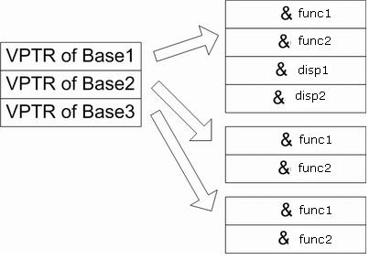
And as seen in the diagram, class Derive, contains the _vptr of all it's base classes.
Also, you can notice that, Derive class's only methods will be listed after it's first Base class's virtual methods i.e. class Base1
Here is the diagram that shows the complete picture of Derive class object i.e. obj in the code.
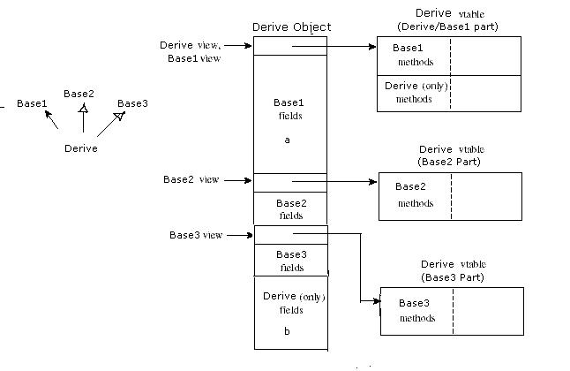
Wherein, it initially contains the first base class's i.e Base1's _vptr and it's data i.e. int a. Then contains the next base class's i.e. Base2 _vptr, then it's data (if any). Next, it's third base class i.e. Base3 class's _vptr and it's data.
Then at the end it contains it's own data i.e Derive class's data i.e. int b here the example.

